**Balanced Budget Multiplier ( Sem –II) Dr. Nityananda Patra**

Q. **Balanced Budget Multiplier for an economy in which there is**

**(Date of Lecture 04/03/2019)**

* **(a) Only autonomous or lump-sum taxation,**
* **(b) Taxes are positive function of income**.

1. Given a simple model

Y=C+I0+G0

Where C= C0 +bYd and Yd=Y-T, 0<b<1, T=T0

Thus Y= C0 +bYd+I0+G0

= C0 +b(Y-T0) +I0+G0

* Y-bY= C0-bT0+I0+G0
* Ȳ= ( C0-bT0+I0+G0) /(1-b)

Thus the government multiplier is

= 1/(1-b) …..(1) And the tax multiplier is

= -b/ (1-b)…….. (2)

effect of a one unit increase in government spending matched by a one unit increase in taxation is the sum of (1)&(2). Therefore,

Ȳ = 1/(1-b)+(-b/(1-b)= (1-b)/(1-b) = 1

A change in government spending matched by an equal change in government taxation will have a positive effect on the equilibrium level of income exactly equal to the change in government expenditure and taxation. The multiplier in this case is +1.

(b) Given Y= Y=C+I0+G0

Where C= C0 +bYd and Yd=Y-T, 0<b<1, T=T0+tY and 0<t<1

* Y = C0 +b(Y-T0-tY)+ I0+G0
* Y-bY+btY= C0-bT0+I0+G0
* Y(1-b+bt) = C0-bT0+I0+G0
* Ȳ= (C0-bT0+I0+G0) /(1-b+bt)

Thus,

…… (3)

…… (4)

The combined effect on Ȳ of a one unit increase in government spending and an equal increase in autonomous taxation is the sum of (3)&(4). Thus,

Ȳ = ()

* (1-b)/(1-b+bt)

Which is positive but less than one, 1 because (1-b) < (1-b+bt)

A change in government expenditures equaled by a change in autonomous taxes **when taxes are positively related to income in the model** will have a **positive effect** on the equilibrium level of income, but the **effect is smaller** than the initial change in government expenditure. Hence the multiplier is less than one, 1 because the initial change in taxes (T=T0+tY) is greater than the change in G0.

**Q Explain the Paradox of Thrift. Is it applicable for developing or under developed countries? If not why?**

**(a) Paradox of Thrift when Investment is autonomous.**

**In** the closed economy where there is no government sector as well as foreign trade, output is determined by the level of aggregate demand. This has the implication that if the households for some reasons, want to change their consumption behavior and become more thrifty (inclined to save more), the effect on output will be adverse and saving may actually to increase. Let us assume the following consumption function:

C= 10+3/4Y (or S = 10+1/4Y) and I=20. Equilibrium holds at the value of Y at which

Y= C+I = 10+3/4Y+20

* 30+3/4Y
* (Y-3/4Y)= 30
* Y(1-3/4) = 30
* Y=Y*= 12

Thus equilibrium output, Y* is 120 where S=I=20. A rise in the propensity to save (an upward shift of the S curve) can be represented by a new S function with a higher vertical intercept. Let the new function be

S= -8+1/4Y. With I staying constant at 20, the new equilibrium Y= 112. Attempt to save more has led to a decline in income. Actually, income has declined enough to make the value of S (calculated from the new S function) equal to the constant level of 20 once again. There has been no change in S despite an increase in thriftiness. Figure 1 illustrates the case below:

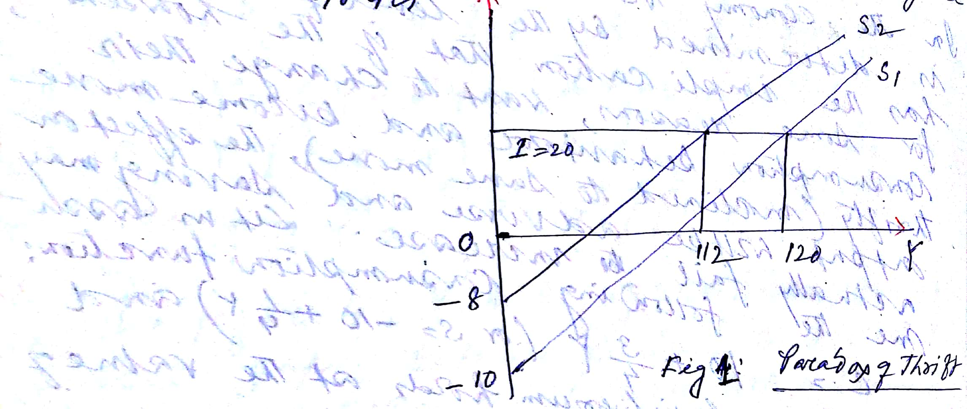

**The reason behind the paradox is that in a situation of widespread unemployment of resources, a cutback in consumption is a bad thing, because it reduces aggregate demand. Consumption spending creates jobs and income in the industries producing consumer goods. So a rise in saving propensity has a depressing effect on income that actually prevents from rising.**

**No, because developing country suffers from capital formation not from lack of demand. This is applicable for developed world.**

(b) Induced Investment and Thrift:

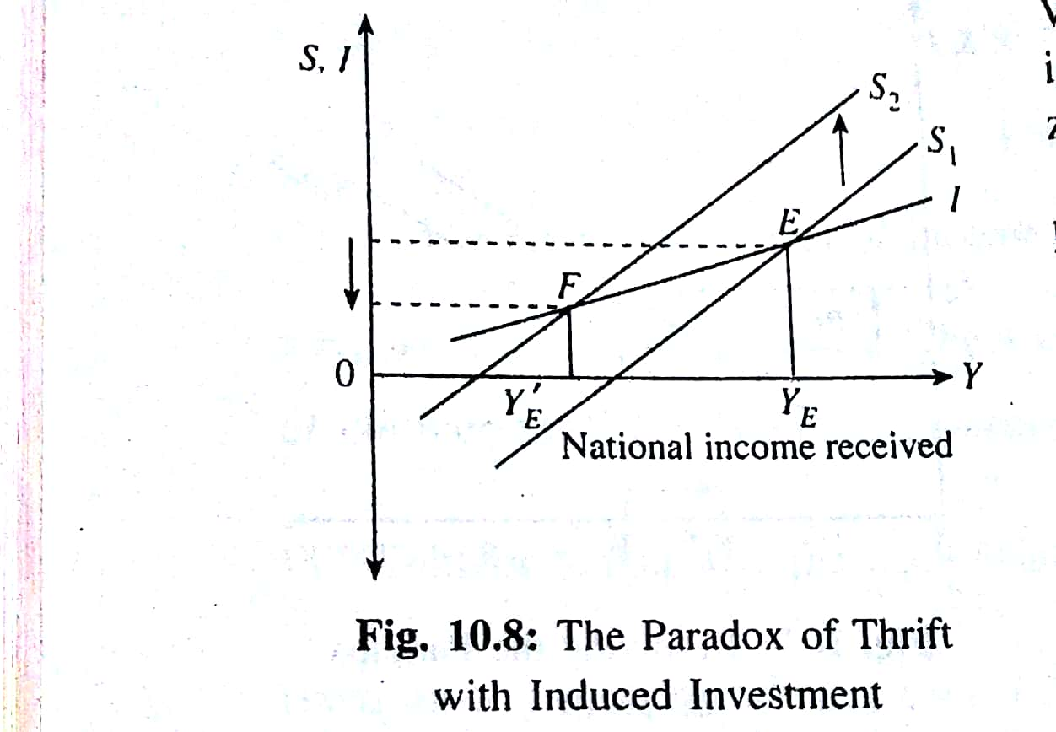The paradox can be developed further if we assume that investment is non-autonomous or induced. We now argue that investment increases with income. So the investment line slopes upward (with positive rather than zero slope). The slope of the line measures the marginal propensity to invest which is expre4ssed as i= . Here ∆Ip is the absolute change in induced private investment and ∆Y is the absolute change in national income. In figure 2 we again consider the effect of an upward shift of the saving schedule. We are now able to explain the paradox fully in the sense that not only does increased saving bring about a lower level of income and investment but it also leads, ultimately, to less being saved. The effect is produced because people now have lesser ability to save at lower levels of income. Their plan (or desire) to save more has been frustrated by the fall in income which a fall in saving causes. The paradox can be stated as follows:

**An increased desire to save may lead to a fall in the actual saving of the community.**(This simply means that sometimes the cure is worse than the disease).

Keynes also pointed out that the effect of increase in thriftiness also depends upon the state of the economy. During inflation an increase in thriftiness or a decrease in consumption expenditure is desirable because it may act an anti-inflationary measure, by eliminating the excess demand pressure. If, on the other hand, the economy suffers from deep depression , with widespread unemployment, the consequence of an increase in thriftiness could be quite disastrous. It would take the economy into a cumulative (vicious) deflationary spiral. Thus if planners and policy makers attempt to ‘tighten our belts’ during depression, the problem is likely to be more serious. In other words, the depression is likely to be made even worse. As J.M. Keynes himself commented:“When you save even five shillings you put a man out of work for a day”